=

Public holiday Guide
  - BIOMEDICAL ENGINEERS
victorian hospital's industrial association – fEb 2024

introduction
The purpose of this Public Holiday Guide is to replace the previous Public Holiday Matrices and summarise the public holiday entitlements afforded to employees under the Biomedical Engineers (Victorian Public Health Sector) Enterprise Agreement 2022-2023(Agreement) for the remaining life of the Agreement until it is replaced.
Members will no longer receive multiple Public Holiday Matrices throughout the year, rather members can use this document to prepare for all public holidays for the remaining life of the Agreement.
VHIA has detailed the known public holidays that occur in 2024. VHIA will provide updated advice to members if the replacement Agreement amends public holiday entitlements.
It is not intended to replace the Agreement or provide an entitlement beyond the Agreement itself.
VHIA encourages members to read the relevant terms of the Agreement alongside this Public Holiday Matrix.

where to find copies of the agreement and other material
VHIA members can access copies of the Agreement and other material (such as Implementation Guides and Salary Circulars) by selecting Biomedical Engineers under ‘My Professions’ on your VHIA Website Dashboard.
For more information about accessing the VHIA Website, please contact vhia@vhia.com.au

WHO TO CONTACT FOR MORE INFORMATION
Members are encouraged to direct any queries in relation to this Public Holiday Guide to query@vhia.com.au

working on a public holiday
Relevant Clause
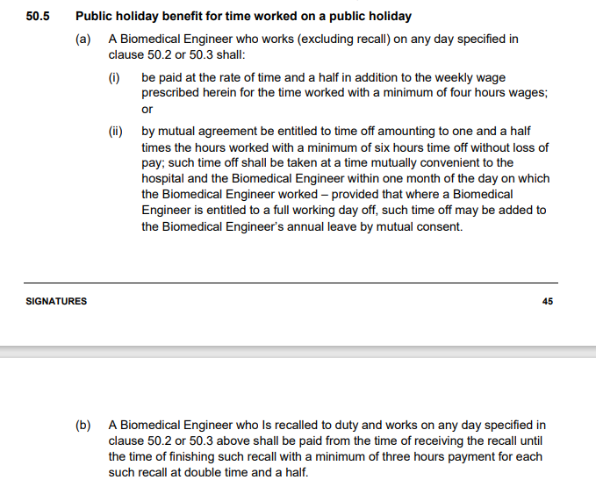

not working on a public holiday
Relevant Clause
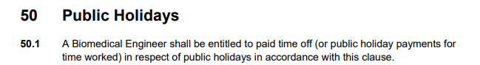
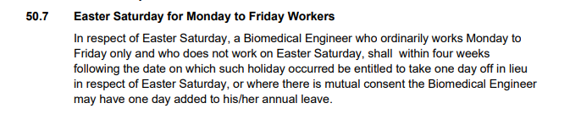
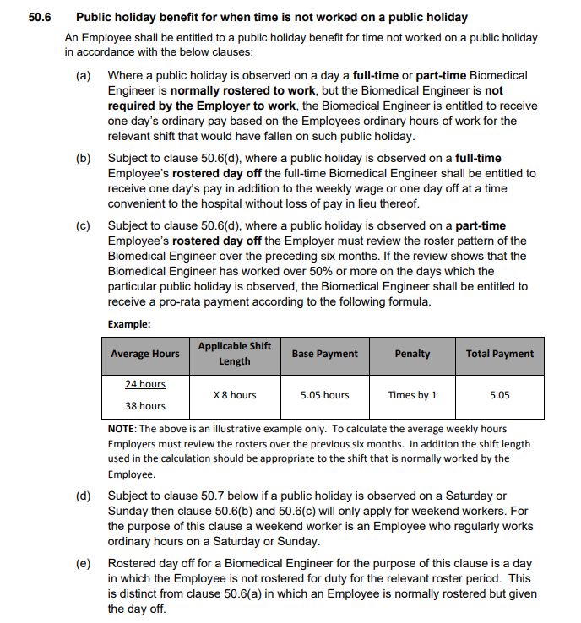

adDitional rules – other leave on public holidays
Leave Type | Impact of taking leave on a Public Holiday
Annual Leave | If the period during which an Employee takes paid annual leave includes a public holiday prescribed by clause 50 (Public Holidays), the Employee is taken not to be on paid annual leave on that public holiday- see sub-clause 51.2
Personal Leave | If the period during which an Employee takes paid personal/carer’s leave includes a day or part day that is a public holiday in the place where the Employee is based for work purposes, the Employee is taken not to be on paid personal/carer’s leave on that public holiday– see sub-clause 54.10
Long Service Leave | Any long service leave shall be inclusive of public holidays occurring during the period when the leave is taken-see sub-clause 61.5
Paid Parental Leave | An Employee on Paid Parental Leave when a public holiday occurs does not receive a public holiday entitlement, nor does it extend the Paid Parental Leave period
Unpaid Leave | If an employee is on Unpaid Leave when a Public Holiday occurs, the employee does not receive a public holiday entitlement.

additional rules – recall on public holiday
Relevant Clause

Table 1: Summary of Public Holiday Entitlements
Full Time | Entitlement | Clause Ref.
Rostered to Work (works on public holiday) | Excluding Recall - 250% (minimum 4 hours pay) or by mutual agreement time off equivalent to time and one half (with a minimum of 6 hours pay) in addition to time worked.  Time off to be taken with one month (mutually convenient to the hospital and the biomedical engineer) or where the Biomedical Engineers works a full day, such time off may be added to A/L  Recall only – 250% (minimum 3 hours pay) from the time of receiving the recall until the time of finishing such recall. | 50.2 and 50.5
Rostered to Work (not required to work) | 1 days ordinary pay at the rostered hours for that day | 50.6(a)
Not Rostered to Work (rostered day off) | 1 days ordinary pay (7.6 hours unless the employee ordinarily works longer shifts) or  1 day off in lieu  Weekend PH (excl. Easter Saturday) (e.g. Easter Sunday):  Employees who are Weekend Workers receive the Not Rostered to Work benefit set out above (100%)  No rostered off penalty applicable if the employee is not a Weekend Worker  Weekend Worker is an Employee who regularly works ordinary hours on a Saturday or Sunday.  Rostered day off for a Biomedical Engineer is a day  in which the Employee is not rostered for duty for the relevant roster period.  Easter Saturday only:  Employees who work Monday to Friday only (must work every day) and don’t work on Easter Saturday are entitled to 1 day TOIL within 4 weeks of Easter Saturday or 1 day added to Annual Leave (with mutual consent) | 50.6(b)  50.6  50.6(d)  50.6(e)  50.7

Part Time | Entitlement | Clause Ref.
Rostered to Work (works on public holiday) | Excluding Recall - 250% (minimum 4 hours pay) or by mutual agreement time off equivalent to time and one half (with a minimum of 6 hours pay) in addition to time worked.  Time off to be taken with one month (mutually convenient to the hospital and the biomedical engineer) or where the Biomedical Engineers works a full day, such time off may be added to A/L  Recall only – 250% (minimum 3 hours pay) from the time of receiving the recall until the time of finishing such recall. | 50.2 and 50.5
Rostered to Work (not required to work) | 1 days ordinary pay at the rostered hours for that day | 50.6(a)
Not Rostered to Work (rostered day off) | Weekdays & Weekend PH (excl. Easter Saturday but includes Weekend Worker Easter Saturday)  Pro-rata payment, equal to their ordinary pay for the average daily hours worked by that employee over the previous six months (e.g. 24  /38 x 8 hours (or usual shift length) = 5.05 hours.  Easter Saturday (M-F workers) only:  Employees who work Monday to Friday only (must work every day) and don’t work on Easter Saturday are entitled to 1 day TOIL within 4 weeks of Easter Saturday or 1 day added to Annual Leave (with mutual consent)  Employees who don’t work Monday to Friday only receive their Easter Saturday entitlement from the pro-rata calculation above. | 50.6(c)  50.7

Casual | Entitlement | Clause Ref.
Rostered to Work | 312.5% | Undertaking
Not Rostered to Work | No rostered off benefit unless they are required to work on that day | Silent

Table 2: public holidays occuring until nominal expiry date
Note: Public Holidays falling on a weekend are marked in bold

2024
New Years Day – 1 January 2024 | Australia Day – 26 January 2024
Labour Day – 11 March 2024 | Good Friday – 29 March 2024
Saturday before Easter Saturday – 30 March 2024 | Easter Sunday – 31 March 2024
Easter Monday -1 April 2024 | ANZAC Day – 25 April 2024
King’s Birthday – 10 June 2024 | Friday before AFL Grand Final – 27 September 2024
Melbourne Cup – 5 November 2024 | Christmas Day – 25 December 2024
Boxing Day – 26 December 2024
Source - Victorian public holidays 2024 | Business Victoria

Melbourne Cup Day is a public holiday across all of Victoria unless alternate local holiday has been arranged by a non-metro council.

