Public holiday
Guide
  - Doctors in Training
victorian hospital's industrial association – Feb 2024

introduction
The purpose of this Public Holiday Guide is to replace the previous Public Holiday Matrices and summarise the public holiday entitlements afforded to employees under the Doctors in Training (Victorian Public Health Sector) (AMA Victoria/ASMOF) (Single Interest Employers) Enterprise Agreement 2022-2026 (Agreement) for the remaining life of the Agreement until it is replaced.
Members will no longer receive multiple Public Holiday Matrices throughout the year, rather members can use this document to prepare for all public holidays for the remaining life of the Agreement.
VHIA has detailed the known public holidays that occur between the publication date of this Public Holiday and the nominal expiry date of the Agreement, 28 February 2026. VHIA will provide updated advice to members closer to that date where the Agreement is anticipated to operate beyond the nominal expiry date.
It is not intended to replace the Agreement or provide an entitlement beyond the Agreement itself.
VHIA encourages members to read the relevant terms of the Agreement alongside this Public Holiday Matrix.

where to find copies of the agreement and other material
VHIA members can access copies of the Agreement and other material (such as Implementation Guides and Salary Circulars) by selecting Doctors in Training under ‘My Professions’ on your VHIA Website Dashboard.
For more information about accessing the VHIA Website, please contact vhia@vhia.com.au

WHO TO CONTACT FOR MORE INFORMATION
Members are encouraged to direct any queries in relation to this Public Holiday Guide to query@vhia.com.au

working on a public holiday
Relevant Clause
Note: A casual Doctor in Training not entitled to penalty payments for work performed on a public holiday except in limited circumstances set out in sub-clause 63.3 and summarised below under Additional Rules – Public Holidays falling on a Weekend
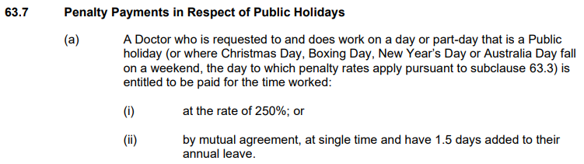

not working on a public holiday – FULL TIME
Relevant Clause
Note: The definition of Actual Day and Other Day can be found in sub-clause 63.3 and summarised below under Additional Rules – Public Holidays falling on a Weekend
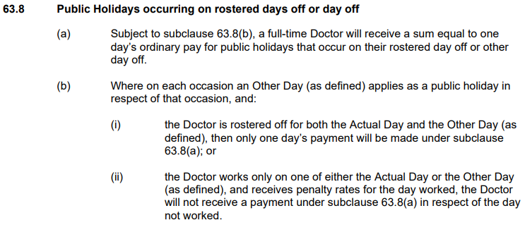

not working on a public holiday – PART TIME
Relevant Clause

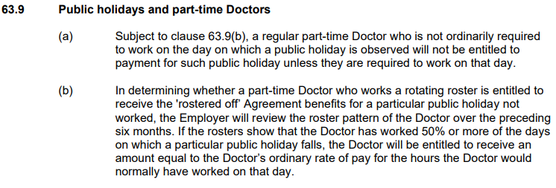

additional rules – public holidays falling on weekend
Note: The only public holiday where this occurs for the remaining life of the Agreement is Australia Day 2025; casual Doctors in Training are entitled to penalty payments for work performed on public holidays pursuant to this clause only.
Relevant Clause
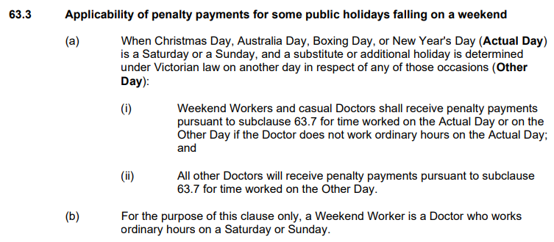

additional rules – other leave on public holidays
Leave Type | Impact of taking leave on a Public Holiday
Annual Leave | The employee receives their public holiday not worked entitlement and doesn’t have Annual Leave deducted from their credits – see Section 89, Fair Work Act
Personal Leave | The employee receives their public holiday not worked entitlement and doesn’t have paid personal leave deducted from their credits – see subclause 61.7
Long Service Leave | If an employee is on Long Service Leave when a Public Holiday occurs, the employee does not receive a public holiday entitlement, nor does it extend the Long Service Leave period - see subclause 68.6
Paid Parental Leave | An Employee on Paid Parental Leave when a public holiday occurs does not receive a public holiday entitlement, nor does it extend the Paid Parental Leave period
Unpaid Leave | If an employee is on Unpaid Leave when a Public Holiday occurs, the employee does not receive a public holiday entitlement.

additional rules – recall on public holiday
Relevant Clause
Note: This clause provides that a Doctor in Training who has an entitlement to a public holiday benefit on a day they are not working will be guaranteed the rostered off benefit afforded to them under subclause 63.8 or 63.9 in addition to any recall payment they receive – regardless of the time of the day the recall occurs.
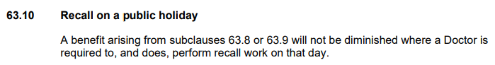
VHIA and AMA Victoria/ASMOF have agreed to the below methodology in managing recall on a public holiday, it is anticipated that this will be addressed in the next round of bargaining:

Where the Doctor was rostered to work, but not required to work on the Public Holiday and was oncall:

- If the recall occurs on a day that the Doctor would have ordinarily worked, the Doctor receives recall payments at the appropriate overtime rate for the time they are recalled, and one day’s ordinary pay, regardless of where the recall falls

Example:
A Doctor is rostered to work from 0700 - 1700, but not required to work on Christmas Day. The Doctor is on-call and is recalled from 1200 – 1600. The Doctor would be paid 10 hours PH Not Worked (100%) and 4 hours at the appropriate overtime rate.

Where the Doctor was not rostered to work and received a rostered off benefit on the Public Holiday and was oncall:

- If the Doctor is recalled on a day they are receiving a rostered off benefit, the Doctor receives recall payments at the appropriate overtime rate for the time they are recalled, and the one days ordinary pay arising from the rostered off benefit, regardless of when the recall occurred.

Example:
A Doctor is in receipt of a rostered off benefit on Christmas Day. The Doctor is on-call and is recalled from 1200 - 1600. The Doctor would receive their one day’s ordinary pay, the hours worked as recall from 1200 - 1600 are paid at the appropriate overtime rate.

Table 1: Summary of Public Holiday Entitlements

Full Time | Entitlement | Clause Ref.
Rostered to Work (works on public holiday) | 250% or 100% + 1.5 days added to A/L balance | 63.7
Rostered to Work (not required to work) | 1 days ordinary pay at the rostered hours for that day | 63.6
Not Rostered to Work (rostered day off or other day off) | Weekdays & Weekend PH (incl. Easter Saturday)  1 days ordinary pay (7.6 hours unless the Doctor ordinarily works longer shifts) | 63.8(a)

Part Time | Entitlement | Clause Ref.
Rostered to Work (works on public holiday) | 250% or 100% + 1.5 days added to A/L balance | 63.7
Rostered to Work (not required to work) | 1 days ordinary pay (7.6 hours unless the Doctor ordinarily works longer shifts) | 63.6
Not Rostered to Work (rostered day off or other day off) | Weekdays & Weekend PH (incl. Easter Saturday)  1 days ordinary pay (7.6 hours unless the Doctor ordinarily works longer shifts) where the Doctor has worked – subject to meeting the below  Over the preceding six months, if the rosters show that the Doctor has worked 50% or more of the days on which a particular public holiday falls, the Doctor will be entitled to receive an amount equal to the Doctor’s ordinary rate of pay for the hours the Doctor would normally have worked on that day | 63.9

Note: Casuals only receive a public holiday benefit on Australia Day 2025; and not any other Public Holidays
Casual | Entitlement | Clause Ref.
Worked ordinary hours on 26 January 2025 (Actual Day) only | 250% | 63.3(a)

Table 2: public holidays occuring until nominal expiry date
Note: Public Holidays falling on a weekend are marked in bold
2024
New Years Day – 1 January 2024 | Australia Day – 26 January 2024
Labour Day – 11 March 2024 | Good Friday – 29 March 2024
Saturday before Easter Saturday – 30 March 2024 | Easter Sunday – 31 March 2024
Easter Monday -1 April 2024 | ANZAC Day – 25 April 2024
King’s Birthday – 10 June 2024 | Friday before AFL Grand Final – 27 September 2024
Melbourne Cup – 5 November 2024 | Christmas Day – 25 December 2024
Boxing Day – 26 December 2024
Source - Victorian public holidays 2024 | Business Victoria
2025
New Years Day – 1 January 2025 | Australia Day – 26 January 2025 (A) & 27 January 2025 (O)
Labour Day – 10 March 2025 | Good Friday – 18 April 2025
Saturday before Easter Saturday – 19 April 2025 | Easter Sunday – 20 April 2025
Easter Monday – 21 April 2025 | ANZAC Day – 25 April 2025
King’s Birthday – 9 June 2025 | Friday before AFL Grand Final – TBC
Melbourne Cup – 4 November 2024 | Christmas Day – 25 December 2024
Boxing Day – 26 December 2024
Source: Victorian public holidays 2025 | Business Victoria

2026
New Years Day – 1 January 2026 | Australia Day – 27 January 2026
Labour Day – 9 March 2026 | Good Friday – 3 April 2026
Saturday before Easter Saturday – 4 April 2026 | Easter Sunday – 5 April 2026
Easter Monday - 6 April 2026 | ANZAC Day – 25 April 2026

Melbourne Cup Day is a public holiday across all of Victoria unless alternate local holiday has been arranged by a non-metro council.
ANZAC Day is commemorated on the day it falls. There is no replacement holiday when ANZAC Day falls on a weekend.

