=

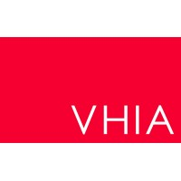
Public holiday Guide
  - DENTAL THERAPISTS, DENTAL HYGIENISTS AND ORAL HEALTH THERAPISTS’
victorian hospital's industrial association – feb 2024

introduction
The purpose of this Public Holiday Guide is to replace the previous Public Holiday Matrices and summarise the public holiday entitlements afforded to employees under the Dental Therapists, Dental Hygienists and Oral Health Therapists’ (Victorian Public Health Sector) (Single Interest Employers) Enterprise Agreement 2022-2023(Agreement) for the remaining life of the Agreement until it is replaced.
Members will no longer receive multiple Public Holiday Matrices throughout the year, rather members can use this document to prepare for all public holidays for the remaining life of the Agreement.
VHIA has detailed the known public holidays that occur between the publication date of this Public Holiday and the nominal expiry date of the Agreement, 30 April 2023. VHIA will provide updated advice to members closer to that date where the Agreement is anticipated to operate beyond the nominal expiry date.
It is not intended to replace the Agreement or provide an entitlement beyond the Agreement itself.
VHIA encourages members to read the relevant terms of the Agreement alongside this Public Holiday Matrix.

where to find copies of the agreement and other material
VHIA members can access copies of the Agreement and other material (such as Implementation Guides and Salary Circulars) by selecting Dental Therapists, Dental Hygienists and Oral Health Therapists’ under ‘My Professions’ on your VHIA Website Dashboard.
For more information about accessing the VHIA Website, please contact vhia@vhia.com.au

WHO TO CONTACT FOR MORE INFORMATION
Members are encouraged to direct any queries in relation to this Public Holiday Guide to query@vhia.com.au

working on a public holiday
Relevant Clause
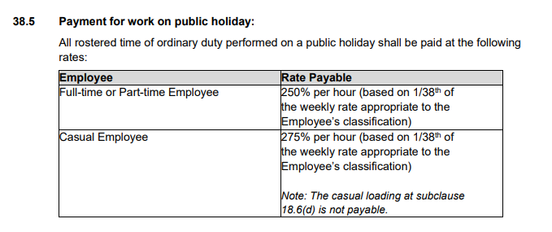

not working on a public holiday – FULL TIME
Relevant Clause
Note: The definition of Actual Day and Other Day can be found summarised below under Additional Rules – Public Holidays falling on a Weekend

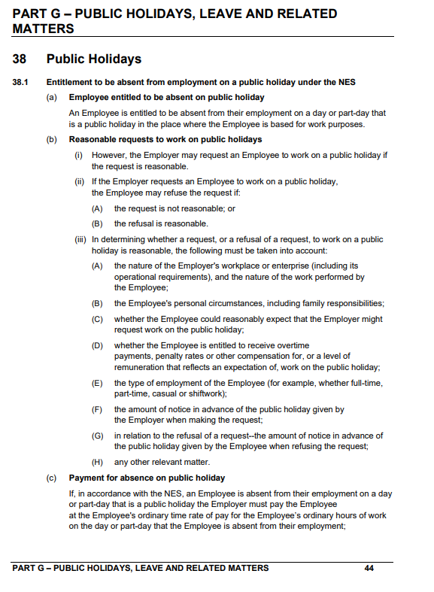
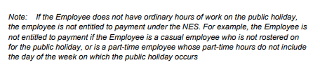

additional rules – other leave on public holidays
Leave Type | Impact of taking leave on a Public Holiday
Annual Leave | Annual Leave shall be exclusive of the Public Holidays provided for in this Agreement
Personal Leave | If the period during which an Employee takes paid personal leave includes a day or part-day that is a public holiday in the place where the Employee is based for work purposes, the Employee is taken not to be on paid personal leave on that public holiday– see sub-clause 43.6
Long Service Leave | Any long service leave shall be inclusive of any public holiday occurring during the period when the leave is taken-see sub-clause 52.8
Paid Parental Leave | An Employee on Paid Parental Leave when a public holiday occurs does not receive a public holiday entitlement, nor does it extend the Paid Parental Leave period
Unpaid Leave | If an employee is on Unpaid Leave when a Public Holiday occurs, the employee does not receive a public holiday entitlement.

Table 1: Summary of Public Holiday Entitlements

Full Time | Entitlement | Clause Ref.
Rostered to Work (works on public holiday) | 250% | 38.5
Rostered to Work (not required to work) | 1 days ordinary pay at the rostered hours for that day | 38.1
Not Rostered to Work (rostered day off or other day off) | Weekdays & Weekend PH (including Easter Saturday)  No entitlement to not rostered to work | Silent

Part Time | Entitlement | Clause Ref.
Rostered to Work (works on public holiday) | 250% | 38.5
Rostered to Work (not required to work) | 1 days ordinary pay at the rostered hours for that day | 38.1
Not Rostered to Work (rostered day off or other day off) | Weekdays & Weekend PH (including Easter Saturday)  No entitlement to not rostered to work | Silent

Casual | Entitlement | Clause Ref.
Rostered to Work | 275% | 38.5
Not Rostered to Work | No rostered off benefit unless they are required to work on that day | 38.1

Table 2: public holidays occuring until nominal expiry date
Note: Public Holidays falling on a weekend are marked in bold

2024
New Years Day – 1 January 2024 | Australia Day – 26 January 2024
Labour Day – 11 March 2024 | Good Friday – 29 March 2024
Saturday before Easter Saturday – 30 March 2024 | Easter Sunday – 31 March 2024
Easter Monday -1 April 2024 | ANZAC Day – 25 April 2024
King’s Birthday – 10 June 2024 | Friday before AFL Grand Final – 27 September 2024
Melbourne Cup – 5 November 2024 | Christmas Day – 25 December 2024
Boxing Day – 26 December 2024
Source - Victorian public holidays 2024 | Business Victoria

Melbourne Cup Day is a public holiday across all of Victoria unless alternate local holiday has been arranged by a non-metro council.

