PIVC WORKSHOP DATES 2026
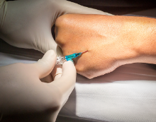

10.2.26 | 23.7.26
26.2.26 | 10.8.26
10.3.26 | 17.9.26
16.3.26 | 15.10.26
9.4.26 | 17.11.26
11.5.26 | 1.12.26
18.6.26

pivc WELEARN TO be COMPLETED prior TO attending the workshop

SESSION TIMES: 1400 – 1515
VENUE: Sunshine Hospital WHCRE
Level 2 Simulation Lab Part Task Room

Target Audience: This course is recommended for all nursing staff.
Enroll via Welearn: https://welearn.wh.org.au
Inquiries Email: Welearn@wh.org.au

Educators:
Christine Raguz CNE
Janet Monohan CNE

12/03/2025 Wednesday, Lecture Theatre, Sunshine Hospital

24/06/2025 Tuesday, Lecture Theatre, Sunshine Hospital

28/10/2025 Tuesday, Lecture Theatre, Sunshine Hospital

Educators:
Soumya Arun, CNE

Target Audience: This course is recommended for all nursing staff.
Enroll via Welearn: https://welearn.wh.org.au
Inquiries Email: Welearn@wh.org.au

