




Graduate Nurse Program
2027
Information Handbook



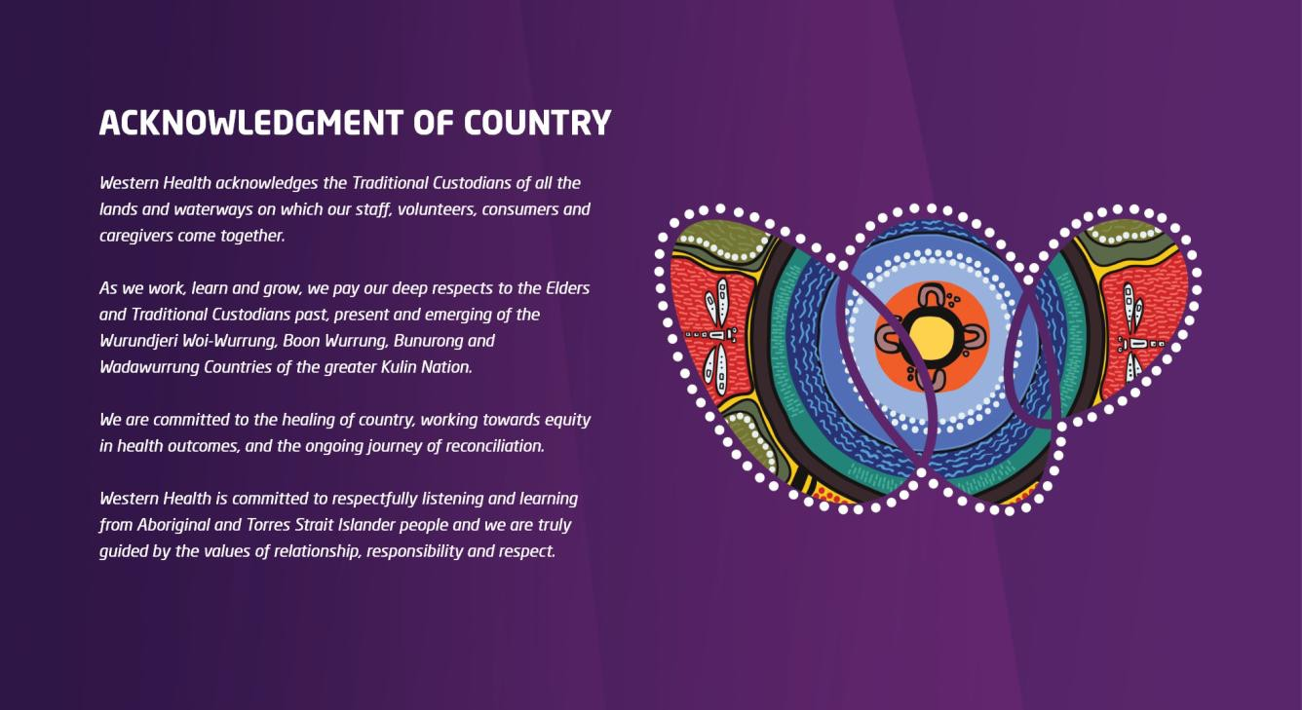

Contents

Western Health – Vision, Values, Purpose, Priority 4
About us 5
Graduate Nurse Program Year One 8
Grad + Year Two 10
Program Overview 11
Professional Development 12
Beyond Your Graduate Program 12
Combined Mental Health & Nursing Program 13
GNP Information Sessions 14
How to Apply 14
Graduate Experiences 15
Contact Us 16


Our Vision
Together, caring for the West
Our patients, staff, community and environment

Our Values
Compassion
Consistently acting with empathy and integrity. Accountability
Taking responsibility for our decisions and actions. Respect
Respect for the rights, beliefs and choice of every individual. Excellence
Inspiring and motivating, innovation and achievement. Safety
Prioritising safety as an essential part of everyday practice.

Our Purpose
Working collaboratively to provide quality health and well-being services for the people of the West.



Our Priority





Safe and effective patient care People and culture Community and partnerships

Research and learning

Self-sufficiency and sustainability

About Us
Western Health provides a comprehensive, integrated range of services from its various sites, ranging from mental health and wellbeing services, and acute tertiary services in areas of emergency, medicine, intensive care, medical and surgical services, through to subacute care and onsite and virtual ambulatory clinics.
Western Health’s specialised services include oncology, renal, women’s health including maternity, chronic
disease, geriatrics and cardiology.
Western Health provides a combination of hospital, community-based and in-reach to aged, adult and paediatric patients and newborn babies and also provides the primary health care service at the Dame Phyllis Frost Centre and community Drug Health services.

Employing over 12,500 staff, Western Health has a strong philosophy of working with its local community to deliver excellence in patient care. Western Health has long-standing relationships with health providers in the Western region of Melbourne and strong affiliations with numerous colleges and academic institutions.

Our Community:

Is amongst the fastest growth corridors in Australia Has a population in excess of 900,000 people
Has a diverse social and economic status making it one of the most culturally diverse communities in the state with more than 150 different languages and dialects

Western Health’s catchments include the following local government municipalities:

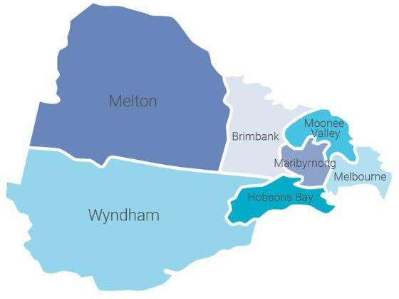
Brimbank Hobsons Bay Maribyrnong Melton Moonee Valley Moorabool Hume Wyndham


6

Closing the Gap
Western Health is committed to achieving equality in health status between Aboriginal and Torres Strait Islander peoples and non-indigenous Australians, improving the health of Indigenous Australians residing in the Western suburbs.

Western Health is one of the largest providers of healthcare in Victoria. It manages four acute public hospitals: Footscray Hospital, Sunshine Hospital, Williamstown Hospital and Bacchus Marsh Hospital. It also operates at various other sites committed to providing Best Care to communities across Melbourne’s west, improving health outcomes for all.

Our Sites:
- Sunshine Hospital
- Sunshine Joan Kirner Women’s & Children’s
- Footscray Hospital
- Williamstown Hospital
- Bacchus Marsh Hospital
- Melton Regional Hospital

Western Health also operates:
- Mental Health and Wellbeing Centre (new in Sunshine)
- Bacchus Marsh Community Health Centre
- Grant Lodge Residential Aged Care (Bacchus Marsh)
- Melton Health & Community Services
- Caroline Springs Community Health Centre
- Sunbury Community Hospital

Footscray Hospital
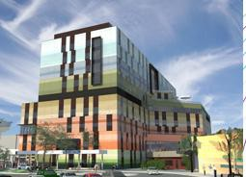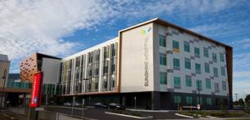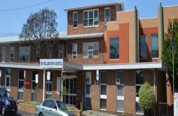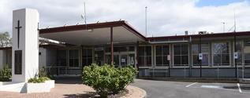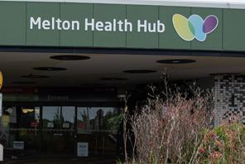
Joan Kirner Sunshine Hospital Williamstown Hospital Bacchus Marsh Melton Health Hub
Women’s & Children’s

Western Health is fast growing and expanding its sites!

Footscray Hospital


The Victorian government has provided up to $1.5 billion to deliver a new Footscray Hospital.
The new Footscray Hospital- the largest ever health infrastructure investment in the State – has an increase of nearly 200 beds and will treat approximately 15,000 additional patients and enable around 20,000 additional people to be seen by the emergency department each year. The hospital is a major teaching hospital responsible for providing acute general medical and surgical, intensive and coronary care, subspecialty medicine, surgical services, mental health and related clinical support. Opened 18 February 2026.

New Melton Hospital


The Victorian government has committed more than $900 million to deliver a new Melton Hospital.
Victoria’s first all-electric hospital will support the growing and diverse communities in Melbourne’s west. Generating more than 3,975 healthcare related jobs, it will have the capacity to treat 130,00 patients each year and 60,000 patients in the ED department alone. Construction is now underway, with the hospital expected to open in 2029.

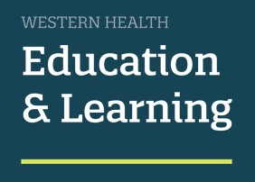
Graduate Nurse Program Grad + Program* *optional to apply
We offer a comprehensive program, to assist you with transitioning to the role of registered nurse. This program will enable you to deliver safe, effective patient care in a supportive environment.

Aim
The aim of this program is to develop graduate nurses who are resilient, reflective practitioners whilst learning clinical reasoning skills and demonstrating safe and effective care of patients at all times.

Learning Outcomes
By the completion of your graduate program, you should be able to:

- Demonstrate resilience in your working life and have developed strategies to deal with difficult situations
- Effectively plan for the day and seek help at appropriate times
- Demonstrate the ability to perform all the clinical skills you have learnt during the program
- Demonstrate the ability, at a beginning level, to utilise clinical reasoning in your daily practice
- Reflect on your practice and strive towards constant improvement
- Demonstrate the ability to recognise deterioration and escalate appropriately

Support
We are committed to offering a supportive program during your graduate years:

- A hospital orientation day and two graduate study days when you commence
- In each of your rotations you will be allocated a preceptor
- On each ward there is a ward-based educator who will assist you in your transition and offer you a range of learning experiences throughout the program
- Your ward educator will complete your appraisals
- Five supernumerary days for your first rotation, and two for your second rotation
- Two further graduate specific study days
- Regular debrief sessions throughout the program
- A monthly debrief and regular on-line mini modules with associated bedside coaching for the remainder of the program of the first year
- Two academic subjects that attract university credit in your second year (Grad + Program)

Grad + Program

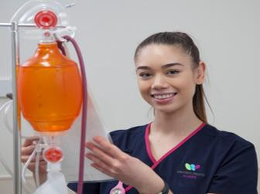

Participants offered option to stream into areas of interest

Expectations

Graduate Nurse Program (Year 1)

Participants offered up to two additional rotations
in areas of your choice*
- Attendance at all graduate study days

- Completion of all mandatory competencies

Participants to complete up to two university accredited subjects
at
no cost

- Completion of a project in each rotation

- Successful completion of all requirements of the graduate nurse program

Grad + Program* (Year 2)

Participants to receive individualised career planning
to assist with career goals.

*Optional

Following the completion of the Graduate Nurse Program (GNP), graduates have the option to apply to participate in an extended
Grad + Program

- Completion of additional rotation/s
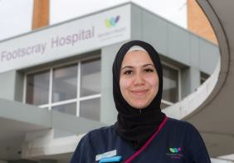
- Successful completion of all requirements of Grad + Program (Year 2)



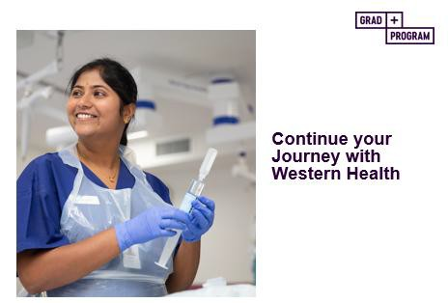
Graduate Nurse Program (Year 1)

Rotations
Western Health offers two rotations during the first year, designed to consolidate nursing knowledge and clinical skills within a supportive learning environment.

We offer a broad range of clinical areas for graduates to work in. Graduates are invited to nominate rotation preferences, which are considered when allocating placements for the year.

During the first year of the program, rotation opportunities may include:
- General Medicine
- General Surgical
- Acute Aged Care
- Infectious diseases
- Oncology
- Orthopaedics
- Palliative Care
- Plastics
- Rehabilitation
- Urology
- Respiratory Medicine
- Sub-Acute Care
- Plastics
- Neurology/Stroke
- Transition Care
- Drug & Alcohol
- Emergency
- Theatre
- CCU
- DPU
- Radiology
- Mental Health
- POOL
Grad + Program *optional (Year 2)

Rotations in areas of your choice*

Participants will have the opportunity to work in at least one of the following specialties (*subject to availability) in two further rotations:
- Drug and Alcohol
- CCU
- ICU
- Dialysis
- Theatres
- Emergency
- Paediatrics
- Newborn Services
- Oncology
- Radiology
- Acute Surgical
- Acute Medical
- Community
- Custodial Health

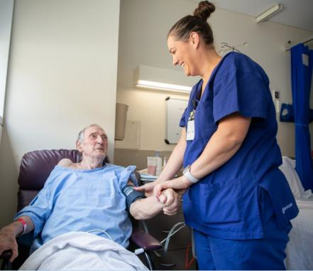

Program Overview:

Program Duration | 54 weeks (x 2 six-month rotations)
Program Intake | 2027 Intake dates:  January 2027 Other intakes TBA
Induction / Orientation | Structured Induction & Orientation Program:  1 Corporate/Hospital Orientation Day (Day 1)  2 Graduate Specific Study Days
Supernumerary Days | 5 Supernumerary Days (Rotation 1)  2 Supernumerary Days (Rotation 2)
Clinical Support | Assigned Preceptor  Assigned ward-based Clinical Nurse Educator/ Clinical Support Nurse  Nurse Unit Manager
Study Days Education Sessions Debrief Sessions | 2 Study Days (additional days during GNP) Monthly graduate specific education sessions Monthly group debrief sessions
Professional Development Days | 1 Professional Development Day in a clinical area of your choice  1 Professional Development Day shadowing an ANUM/NIC
Employment | As per Nurses & Midwives Award 2024-2028 (Victorian Public Sector)  5 weeks annual leave  7-day Rotating Roster – Graduates will be rostered to work across all shifts, including night duty and weekends  Western Health promotes and supports work-life balance and graduate contracts are 0.8 EFT – part-time 64 hours per fortnight
Beyond the Graduate Nurse Program | Postgraduate opportunities

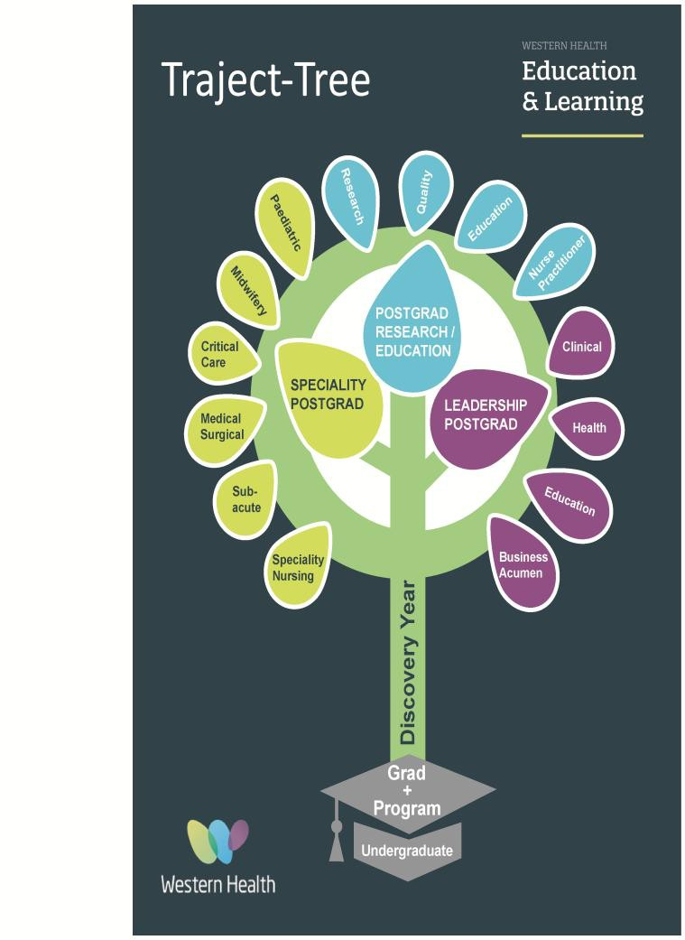
PROFESSIONAL DEVELOPMENT DAYS
Western Health offers a wide range of professional development opportunities coordinated by the Education and Learning Department.
Professional development days during your graduate program:

One professional development day in a clinical area of your choice.

One professional development day shadowing the ANUM/Nurse-in-Charge to support the development of your leadership skills.

ONGOING SUPPORT & LEARNING

Graduate Online Learning Portal Mini Modules Education Plan
Clinical Skills Days Transition Plan



Beyond your Graduate Program
Western Health is a Registered Training Organisation that provides staff with an opportunity to complete accredited training on-site. We are pursuing multi-disciplinary approaches, patient-centred care and lifelong learning to develop & foster a highly skilled workforce which will support excellence in practice and career progression opportunities.

Postgraduate programs and short courses are available to staff. All programs incorporate content on current trends, research and best practice standards and utilise the services of suitably qualified and vocationally experienced educators and clinicians.
Postgraduate study scholarships are also on offer for those undertaking formal postgraduate programs to receive financial assistance to support the cost of their studies.


Combined Mental Health & Nursing Graduate Program

The Sunshine Mental Health and Wellbeing Centre provide graduates with learning opportunities and experiences in the provision of mental health services for communities. The centre is a 52-bed unit designed to deliver exceptional care environments and is created to tailor solutions that address the mental health needs of diverse and expanding communities.
The Sunshine Mental Health and Wellbeing Centre are a multi-storey facility with two Mental Health Adult Acute Units, each comprising of 26 beds.

- 6 intensive care beds, referred to as Intensive Care Area (ICA)
- 6 medium care beds, referred to as Medium Care Area (MCA)
- 14 general care beds, referred to as General Care Area (GCA)

Our combined Mental Health and Nursing graduate program is a comprehensive program that has been developed for nurses passionate about general nursing and mental health. The 54-week program consists of a 6-month rotation in Nursing and a 6-month rotation in Mental Health. Rotations across both streams promotes competence in both nursing practice and mental health nursing practice.
The program includes one full day orientation, study days, debrief sessions and regular education and training, supported by experienced ward-based educators and staff.

The mental health rotation will provide experience in mental health assessment and advice, in consultation with multidisciplinary teams.

- Ability to recognise and facilitate treatment of mental health disorders.
- Recovery and wellness plans based on the needs & preferences of the consumer and their family/carer.

- Mental Health education unit for further education and support.
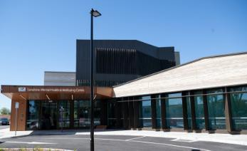

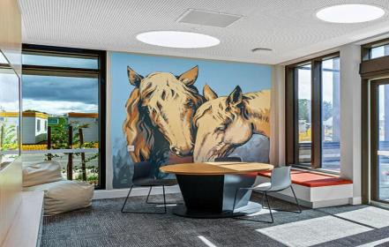

GNP Information Sessions:

We invite you to come along to one of our GNP information sessions to find out more about the Graduate Nurse Program.

Graduate Nurse Program Information Sessions:
🖥Thursday 28 May 2026 4:30 pm

EN to RN Information Session:
🖥Friday 29 May 2026 4:30 pm
Sessions will be held via Microsoft Teams, meeting links will be available to join by visiting Western Health website

HOW TO APPLY:
Details of the application process are available on our website and PMCV

- Application criteria
- Application links
- Frequently Asked Questions

CONTACT US:
For more information email or phone:

Jenny Hagan
Graduate Program Coordinator
E: graduatenurses@wh.org.au
T: 0479 177 674
T: 0403 782 934
www.westernhealth.org.au




Graduate Experiences


“I found that overall, Western Health offered great support and provided me with an opportunity to consolidate my skills and further my knowledge. I have also made lifelong friends and networks…” C.L Nursing Graduate

.

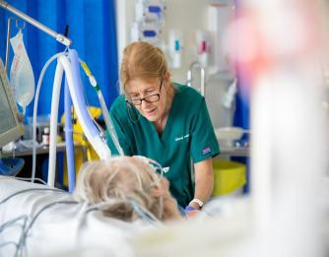
“I chose Western Health as it offered a wide range of clinical areas in a multi-culturally diverse community. I liked the six-month rotations as it was an adequate period of time to settle in, consolidate and develop my skills whilst having a real sense of belonging. M.N. Nursing Graduate

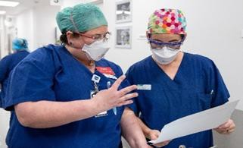
“It has been very beneficial to come together and debrief as a group at the GNP Time Outs where we discuss effective ways to work and problem solve with our graduate educators and preceptors.” C.G . Nursing Graduate

“I love the culture at Western Health. I feel really supported
and I am looking forward to my future opportunties here.
The new Footscray Hospital is exciting and I can’t wait to be part of
what will be a state-of-the-art healthcare precinct.” A.A. Nursing Graduate

“Working in POOL gives me the opportunity to
work across different areas and hospital sites, I
enjoy the flexibility and variety it gives me.“ L .P. Nursing Graduate
“The combined Mental Health & Nursing graduate program has allowed me to develop specialised knowledge and skills in both general and mental health nursing, leading to a diverse skillset. I’m looking forward to the diverse range of career paths it will offer.”
K.W. Combined Mental Health & Nursing Graduate


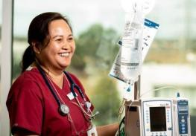
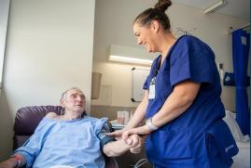

Contact Us
Information Sessions and details of the application process is available at our Graduate Nurse Program webpage
www.westernhealth.org.au

email: graduatenurses@wh.org.au

T: 0403 782 934
T: 0479 177 674

Produced by:
GNP Team
Education and Learning
Level 3 WCHRE Building, Sunshine Hospital 176 – 190 Furlong Road, St Albans VIC 3021 Last updated March 2026
16

