Vascular Surgery Specialist Clinics at Western Health:
Western Health provides Specialist Clinics for patients who require assessment and management of vascular conditions. The Vascular Surgery Unit have developed the following guidelines and associated supporting clinical information to triage your patient appropriately. Please review these guidelines and management via Health Pathways Melbourne before referring a patient to the Vascular Surgery Clinic.
Patients will be triaged into management pathways according to specific clinical requirements.
Please note referrals that do not provide adequate information for triaging may be returned with a request for further information.

Conditions not seen at Western Health Vascular Surgery Clinics:

- Abdominal Aortic Aneurysm <4.5cm in men and <4cm in women
- Femoral or calf DVT – managed by Emergency department
- Aneurysm of the ascending aorta and Type A aortic dissection – refer to Cardiac Surgery
- Intracerebral aneurysms – refer to Neurosurgery
- Cosmetic Varicose Veins or Laser/Injection Sclerotherapy treatment of Spider Veins
- Blushing/Flushing or Excessive Sweating (Hyperhidrosis)
- Lymphoedema- Refer to Melton Western Health Melton Lymphoedema Service , St Vincents Lymphoedema Service - St Vincent's Hospital or Your Community Health-Preston Lymphoedema clinic Lymphoedema | Your Community Health
- Diabetic Foot Ulcers- Chronic ischaemic signs and symptoms of the lower limb WITH foot ulceration, neuropathic or infected ulceration- Refer to Diabetic Foot Unit- see Community Services Referral page

Alarm Symptoms:
Urgent conditions require an immediate referral to an Emergency Department. Support and guidance can be provided by the Western Health Vascular Registrar via switch on 8345 6666.
- Suspected rupture of an abdominal or thoracic aortic aneurysm
- Acute aortic dissection
- Abdominal or thoracic aortic aneurysm >6cm diameter and symptomatic or tender aneurysm
- Critical stenosis of the internal carotid artery associated with transient ischemic attacks (TIA) or stroke
- Carotid Artery dissection or Vertebral Artery dissection
- Acute ischaemia of any limb
- Gangrene or infection or rest pain associated with signs of ischaemia in the leg
- Infection associated with an artery or bypass graft
- Pseudo aneurysm of an artery after trauma or medical intervention/arterial catheter
- Extensive or Ilio-femoral Deep vein thrombosis (DVT)*
- Axillary vein thrombosis

*(refer to Vascular Surgery if requiring opinion and consideration for invasive thrombolysis in addition to anticoagulation. Otherwise manage with anticoagulation under medical unit or in consultation with Haematology)

Access & Referral Priority Vascular Surgery Specialist Clinics:

The clinical information provided in your referral will determine the triage category. The triage category will affect the timeframe in which the patient is offered an appointment.

URGENT  Appointment timeframe 30 days | ROUTINE  Appointment timeframe greater than 30 days, depending on clinical need.
Arterial:  - Carotid Artery Disease  - Symptomatic and >50% stenosis  - Stroke  - Isolated transient ischemic attack (TIA) with reversible ischemic neurological defect (RIND) and/or amaurosis fugax  - Abdominal or thoracic aortic aneurysm >6cm diameter  - Peripheral Vascular Disease  - Ischaemic changes or pain at rest  - Severe claudication <50m  - Popliteal Artery Aneurysm  - Symptoms of claudication or ischaemia  - Significant thrombus within aneurysm >2.0 cm diameter  Venous:  - Venous ulceration  - Bleeding varicosities | Arterial:  - Carotid Artery Disease  - Asymptomatic carotid stenosis of >70% on imaging  - Subclavian stenosis or vertebral steal  - Carotid body tumour  - Abdominal or Thoracic Aortic Aneurysm >4-4.5cm and < 6cm  - Iliac aneurysm  - Splenic, renal or mesenteric artery aneurysm  - Renal Artery Stenosis  - Hypertension  - Deteriorating Renal Function  - Reduction in renal size  - Peripheral Vascular Disease  - Claudication  - Popliteal Artery Aneurysm  - Asymptomatic  - <2.0 cm diameter  Miscellaneous:  - Thoracic Outlet Syndrome  - Mesenteric angina  - Post phlebitis syndrome

Condition Specific Referral Guidelines:
Key information enables Western Health to triage patients to the correct category and provide treatment with fewer visits to specialist clinics, creating more capacity for care. If key information is missing, you may be asked to return the referral with the required information.
Condition: | Key Information Points: | Clinical Investigations Required:
Carotid Artery Disease | - Details of any abnormal examination findings – neurological and cardiovascular  - Details if any History of TIAs (localising, global and amaurosis fugax) or stroke  - Smoking history  - Family history of vascular disease or hyperlipidaemia | - Carotid Artery Duplex Scan  - ECG and cardiac investigations  - FBE U&E LFT, Fasting lipids, INR if on warfarin
Abdominal Aortic Aneurysm | - Medical and surgical history and medications  - Details of genetic factors and collagen disorders  - Smoking history | - Abdominal ultrasound  - FBE, U&E, Fasting lipids
Renal Artery Stenosis | - Medical and surgical history and medications | - Renal Ultrasound, renal artery Duplex Scan  - U&E eGFR  - Copies of past renal ultrasounds (if available)
Peripheral Vascular Disease | - Details of clinical concern, claudication distance, rest pain  - Details of clinical examination – peripheral pulses, skin changes  - Smoking history  - History of spinal conditions | - Duplex ultrasound  - FBE U&E LFT Fasting lipids, coagulation studies, fasting blood glucose, HbA1c(if diabetic)  - CT with contrast (if available)
Varicose Veins | - Referrals will not be accepted without a completed Varicose Vein Supporting Clinical Information Form (Appendix 1)  - CEAP Clinical Score must be ≥C3 (Appendix 2)  - There is an expectation conservative management has been trialed as outlined in Health Pathways Melbourne | - Varicose Vein Form  - CEAP Clinical score  - Outline of medical management trialed
Thoracic Outlet Syndrome | - Symptom duration and history  - Examination findings supporting diagnosis  - Details of management to date | - Any CT/MRI/Xray (if available)  - Ultrasound that provides evidence of vascular anatomical compression (if available)

APPENDIX 1 – VARICOSE VEIN SUPPORTING CLINICAL INFORMATION FORM
HISTORY OF CURRENT CONDITION (OR ATTACHED REFERRAL LETTER)
REFERRER DETAILS
NAME:
CLINIC NAME:
ADDRESS:
PHONE:
FAX:

PATIENT INFORMATION MALE/FEMALE MR/MRS/MS
FIRST NAME: LAST NAME:
DOB: WESTERN HEALTH UR# (IF KNOWN)
ADDRESS:
CONTACT NUMBERS-HOME: MOBILE:
INTERPRETER REQUIRED: YES/NO: if yes LANGUAGE:

Symptoms: __________________________________________________________________________________________________________________________________________________

Conservative Measures: ___________________________________________________________________________________________________________________________________
Exercise | ☐
Compression | ☐ | Type/Grade: __________________________________________________
Injection sclerotherapy | ☐
Clinical conditions:
Venous sclerosis* | ☐
Bleeding varicosities | ☐
Venous dermatitis | ☐
Significant venous oedema | ☐
Thrombophlebitis | ☐
Ulceration | ☐
Weight loss | ☐
Other conditions: | ☐

Previous venous interventions or surgery:___________________________________________________________________________________________________________
Medications:________________________________________________________________________________________________________________________________________________
Other conservative measures:_____________________________________________________________________________________________________________________________

Comorbid conditions: _______________________________________________________________________________________________________________________________________

Functional Limitation circle closest response:
Ankle movement: <50% 50-75% >75%

Walking <100m 100-500m >500m
Body Mass Index: _____________________
* Venous sclerosis- skin changes at the ankle with associated haemosiderin pigmentation causing skin redness, atrophy Blanche and woody induration.

Department of Health Guidelines for Elective Surgery Access in a Public Hospital:https://www.health.vic.gov.au/patient-care/surgical-services-policies-and-guides.
- Please attach current imaging reports and investigation results to referral
- Patients must bring all imaging to appointments

APPENDIX 2 – CEAP CLASSIFICATION OF THE SEVERITY OF VARICOSE VEINS
Clinical Categories:
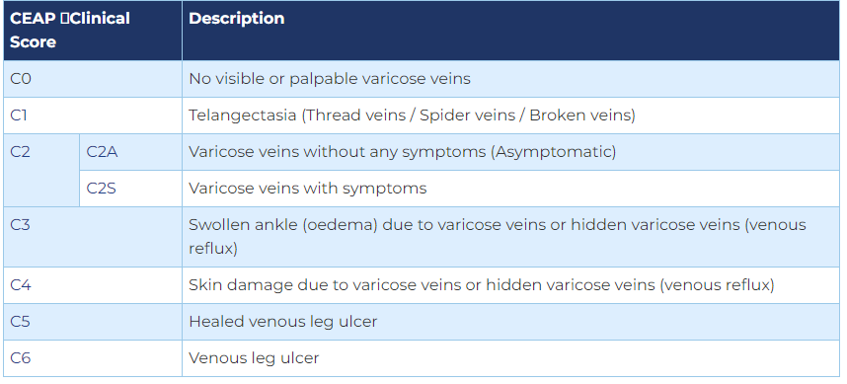
Etiological Classification:
- Ec: Congenital
- Ep: Primary
- Es: Secondary
- En: No venous cause identified

Anatomical Classification:
- As: Superficial veins
- Ap: Perforating veins
- Ad: Deep veins
- An: No venous location identified

Pathophysiology Classification:
- Pr: Reflux
- Po: Obstruction
- Pr.o: Refulx and obstruction
- Pn: No venous pathophysiology identifiable

