Neurosurgery Specialist Clinics at Western Health:

Western Health provides the following Specialist Clinics for patients who require assessment and management of spinal and brain conditions. Patients will be triaged by health professionals into management pathways according to specific clinical requirements (either to the neurosurgery clinic or the physiotherapy led neurosurgery clinic).

Conditions not seen by Neurosurgery Specialists at Western Health:
- Patients experiencing degenerative spinal pain only, consider referral to Pain services- CoHealth Footscray, Western Health Chronic Pain Service, Royal Melbourne Back Assessment Clinic
- Patients with degenerative spine conditions (chronic neck or back pain) where appropriate conservative strategies have not been optimized (in the absence of motor deficits)
- Scoliosis – please refer to Royal Melbourne Hospital Orthopaedic Clinic
- Spinal canal stenosis without neurogenic claudication- refer to physiotherapy
- Carpal Tunnel Surgery- Refer to Plastic and Reconstructive Surgery
- Arachnoid cyst
- Incidental findings on imaging not relating to presenting symptoms
- Intracranial Aneurysm - please refer to Royal Melbourne Hospital Cerebrovascular Clinic
- Pituitary tumours – please refer to Royal Melbourne Hospital Neurosurgery Pituitary Clinic
- Peripheral nerve tumours – please refer to Plastic Surgery Specialist Clinic
- Ulna nerve compression not responding to conservative management - refer to Orthopaedic Specialist Clinic
- Patients not wanting to consider surgery

Neurosurgery Alarm Symptoms:
Any patient presenting with the following should present directly to the nearest emergency department:
- Brain tumours with any of the following:
  - Significant mass effect (especially with midline shift)
  - Significant neurological signs (especially depression of conscious state)
- Pituitary tumours associated with any of the following:
  - Significant intra-cranial mass effect
  - Neurological signs (impairment of vision, or depressed conscious state)
  - Patients with pituitary failure, especially hypotension or hyponatraemia
- Hydrocephalus with any of the following:
  - Acute headache, drowsiness, vomiting with or without VP shunt in situ
  - Other serious neurological disturbance especially papilloedema or 6th nerve palsy
- Vascular lesion (aneurysms, AVMs, vascular conditions) with any of the following:
  - Acute haemorrhage
  - Acute third nerve palsy
  - Other significant neurological disturbance
- Neck or back pain:
  - Acute bacterial infection of the spine (suspected or proven)
  - Neurological disturbance (acute quadriplegia or paraplegia, severe focal weakness not due to pain)
  - Cauda equina symptoms
  - Vertebrobasilar insufficiency symptoms

Access & Referral Priority Neurosurgery:
The clinical information provided in your referral will determine the triage category. The triage category will affect the timeframe in which the patient is offered an appointment.
URGENT  Appointment timeframe 30 days. | ROUTINE  Appointment timeframe greater than 30 days, depending on clinical need.
Neck:  - Neurological deficit due to cord compression (e.g. cervical myelopathy)  - Radicular referred pain to the arm (e.g. severe radicular pain AND significant focal weakness)  - Malignant disease of the spine without neurological disturbance  - Suspected chronic spinal infection | Neck:  - Cord compression on MRI with pain and/or minor disability  - Persistent (>6 weeks) cervical radiculopathy with pain and neurological symptoms
Back:  - Radicular referred pain to the leg (severe pain AND significant focal weakness)  - Neoplastic disease or infection of the spine | Back:  - Significant sciatica without focal motor weakness > 4 weeks duration  - Neurogenic claudication (comes on with walking >200m)
Brain:  - Tumours of moderate dimensions without major neurological disturbance  - Hydrocephalus & periventricular oedema  - Trigeminal neuralgia with severe pain despite medication  - Vascular lesion larger than 5mm in diameter | Brain:  - Incidental small (<1cm) or benign tumours or cysts  - Cavernoma smaller than 5mm diameter (without haemorrhage or significant neurological disturbance)  - Venous malformations

Condition Specific Referral Guidelines:

Key information enables Western Health to triage patients to the correct category and provide treatment with fewer visits to specialist clinics, creating more capacity for care. If key information is missing, you may be asked to return the referral with the required information.

Neck | Key Information Points: | Clinical Investigations:
Cervical Myelopathy | - Completed General Practitioner Referral to Neurosurgery Specialist Clinic Back & Neck Questionnaire (see Appendix 1)  - There is a medical software compatible version of this form available for GPs to download into their software. https://westernhealth.org.au/health-professionals/referrals/how-refer  - Expressed interest in surgical treatment if it is a possible intervention | - Imaging: MRI preferable, if unavailable CT scan  - Include Imaging report & radiology provider details with referral  ->Please note, GP Medicare rebates apply for MRI C-Spine (suspected trauma OR suspected cervical spine radiculopathy). See here for further details.
Cervical Radiculopathy
Neoplastic disease or infection | - Clinical history, examination findings including neurological exam  - Past medical history & current medications | - Imaging: MRI preferable, if unavailable CT scan  - Include Imaging report & radiology provider details with referral  - FBE, CRP & ESR if infection suspected
Back | Key Information Points: | Clinical Investigations:
Radiculopathy | - Completed General Practitioner Referral to Neurosurgery Specialist Clinic Back & Neck Questionnaire (see Appendix 1)  - There is a medical software compatible version of this form available for GPs to download into their software. https://westernhealth.org.au/health-professionals/referrals/how-refer  - Expressed interest in surgical treatment if it is a possible intervention | - Imaging: MRI preferable, if unavailable CT scan  - Include Imaging report & radiology provider details with referral
Neurogenic claudication

Back | - Key Information Points: | - Clinical Investigations:
Neoplastic disease or infection | - Clinical history, examination findings including neurological exam  - Past medical history & current medications | - Imaging: MRI preferable, if unavailable CT scan  - Include Imaging report & radiology provider details with referral  - FBE, CRP & ESR if infection suspected
Brain | Key Information Points: | Clinical Investigations:
Tumours or cysts | - Clinical history, examination findings including neurological exam  - Details of functional deficits  - Past medical history & current medications  - Expressed interest in surgical treatment if it is a possible intervention | - Imaging: MRI preferable, if unavailable CT scan  - Include Imaging report & radiology provider details with referral  -> Please note, GP Medicare rebates apply for MRI Brain (unexplained seizure/s OR unexplained chronic headache with suspected intracranial pathology). See here for further details.
Hydrocephalus & periventricular oedema
Trigeminal neuralgia

Appendix 1: General Practitioner Referral to Neurosurgery Specialist Clinic Back & Neck Questionnaire

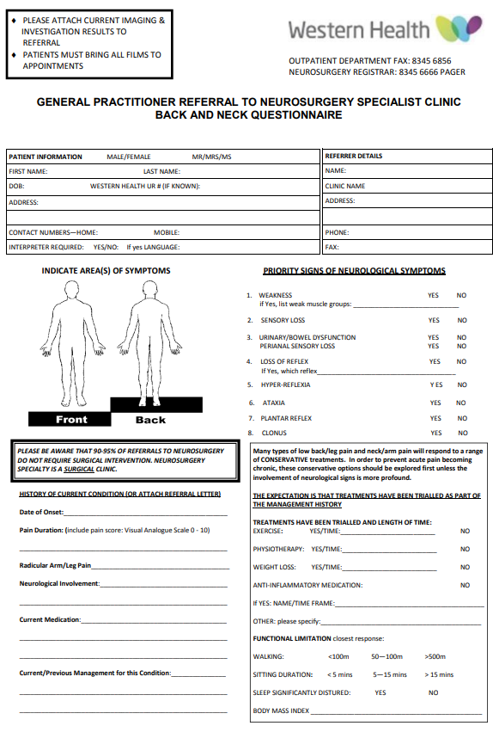

PLEASE ATTACH CURRENT IMAGING & INVESTIGATION RESULTS TO REFERRAL

